Sigmoid Function & Logistic Regression
What It Can Predict, What It Cannot, Limitations, Constraints & Top-10 Applications
Extended educational lab based on C1_W3_Lab02 · Audience-adapted guidance
1. What the Model Can Predict
Under the modeling assumptions (linear logit, independent observations, correctly specified features), a trained logistic regression produces:
• A probability P(y = 1 | x) for each example — a continuous score in (0, 1).
• A hard binary decision after a user-chosen threshold τ (commonly 0.5).
• Interpretable log-odds ratios: a one-unit increase in a feature multiplies the odds by e^{w_i} (when other variables are held constant).
• Ranking of examples by estimated risk / propensity, useful for prioritization even when absolute calibration is imperfect.
2. What the Model Cannot Predict (or Should Not Be Asked to Predict)
• Multi-class or multi-label outcomes without extension (softmax, one-vs-rest, etc.).
• Continuous numeric targets (use linear, Poisson, or other regression families).
• Causal effects (“treatment X causes outcome Y”) from observational data alone. Causal claims require design, instruments, or strong identifying assumptions.
• Highly non-linear decision surfaces unless engineered features, interactions, or a different model family are introduced.
• Reliable forecasts far outside the convex hull of the training features (extrapolation is dangerous).
• “The truth” or objective risk independent of the training population, labeling process, and chosen features.
3. Limitations & Constraints
- Linearity in the logit: the decision boundary is linear in the chosen feature space. Curved or interactive relationships are missed unless features are expanded.
- Sensitivity to outliers and collinearity: extreme points or highly correlated predictors can inflate coefficient variance.
- Class imbalance: default τ = 0.5 can produce poor minority-class recall; threshold tuning or class weights are required.
- Calibration is not automatic: predicted probabilities may be systematically over- or under-confident; post-hoc calibration (Platt, isotonic) is often needed for decision-making.
- Independence assumption: temporal or spatial dependence, repeated measures, or hierarchical structure violate the basic likelihood and require mixed models or GEE-style adjustments.
- Concept drift & population shift: a model trained on one hospital, year, or demographic stratum may degrade when deployed elsewhere.
4. Top-10 Application Domains
- Medical diagnosis & screening (disease present / absent given biomarkers or imaging scores).
- Credit scoring & loan default prediction.
- Spam / phishing / malware detection.
- Customer churn modeling.
- Online advertising click-through rate (CTR) estimation.
- Fraud detection (transaction anomalous or not).
- Sentiment polarity (positive / negative) on short text.
- A/B test or marketing conversion modeling.
- Insurance risk classification (claim / no-claim).
- Early-warning systems in manufacturing or IoT (fault / normal).
5. How to Use It Responsibly
Audience adaptation (drawing on the attached “What to Consider When Considering the Audience” and “Audience and Situation Analysis” guidance):
Data-literate / technical readers (experts, technicians): Supply coefficient tables with standard errors or confidence intervals, ROC/AUC, calibration plots, residual diagnostics, and the exact likelihood assumptions. They can handle scatterplots, boxplots, and the logit transform.
Executives / decision makers: Translate everything into expected counts of false positives / false negatives at the chosen threshold, estimated cost or benefit, and a short “what-if” table. Avoid jargon; lead with the recommendation and the key risk numbers.
Nonspecialists / public / patients: Use frequency language (“roughly 2 out of 10 people with this profile ldots”), emphasize that the score is only one piece of information, and never present the probability as certainty. Highlight that the model was trained on a particular population.
Practical checklist:
- Document training population, time window, inclusion/exclusion criteria, and label definition.
- Choose and justify the decision threshold according to the relative cost of FP vs FN; do not default blindly to 0.5.
- Evaluate on a held-out or temporally forward test set; report uncertainty.
- Monitor for performance drift after deployment; plan re-training triggers.
- For high-stakes domains (health, credit, justice) require human review, fairness audits across protected groups, and clear recourse processes.
- Never claim the model “knows” or “understands”; it produces a statistical association under stated assumptions.
6. Pipeline Flowchart (reference)
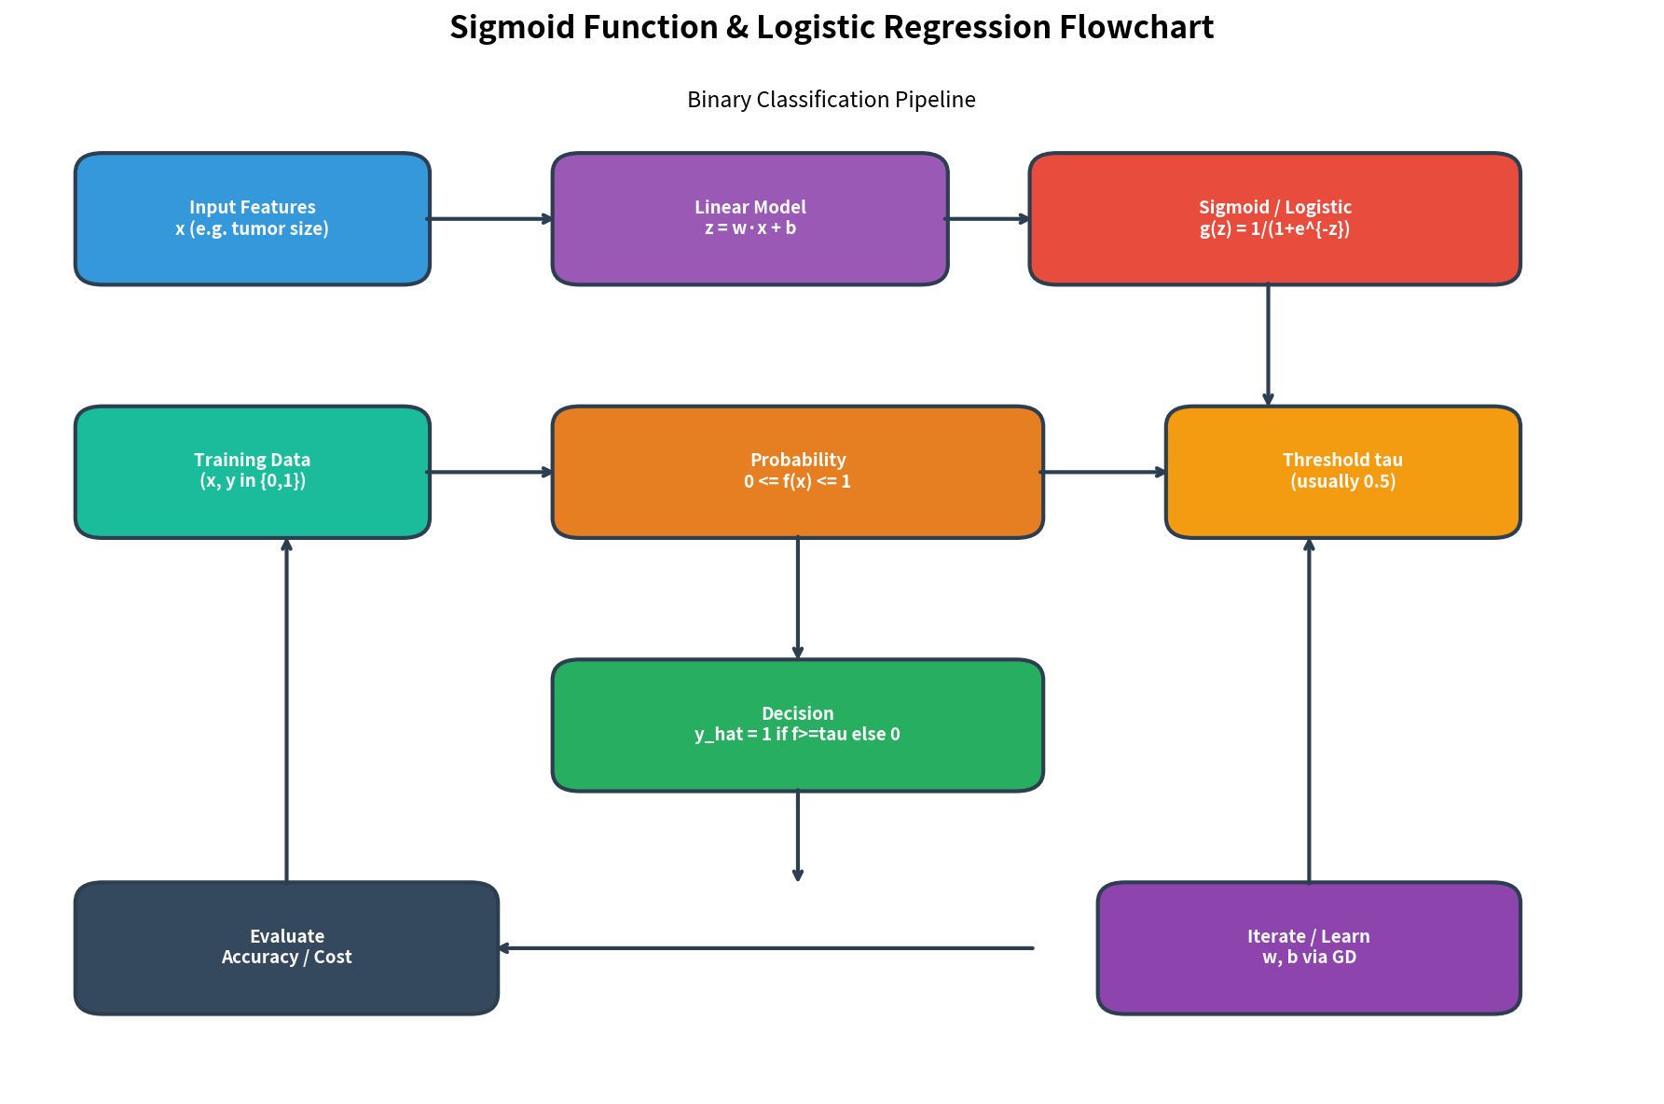
This document accompanies the extended lab notebooks (Practice Skeleton, Solution, Reusable Template) and the 1-page summary report. It is intended to help instructors and practitioners communicate both the power and the proper boundaries of the sigmoid / logistic regression building block.

